

Welcome to the Center for California Real Estate's (CCRE) member marketing toolkit of slides, social posts and video exploring consumer issues in residential real estate. Download these data-driven tools to enhance your marketing plans and spark conversations in your spheres of influence.
As the United States marks its 250th anniversary, we’re taking an opportunity to reflect on the enduring role homeownership has played in the American story. Access to homeownership has expanded over time, shaped by changing economic conditions, public policy, and evolving consumer needs.
Today's buyers continue to view homeownership as a cornerstone of the American Dream, even as affordability challenges reshape the path to ownership. This month’s toolkit provides historical insights, consumer research, and ready-to-use marketing resources that celebrate 250 years of American homeownership while helping you educate clients and demonstrate your REALTOR® value.

 | 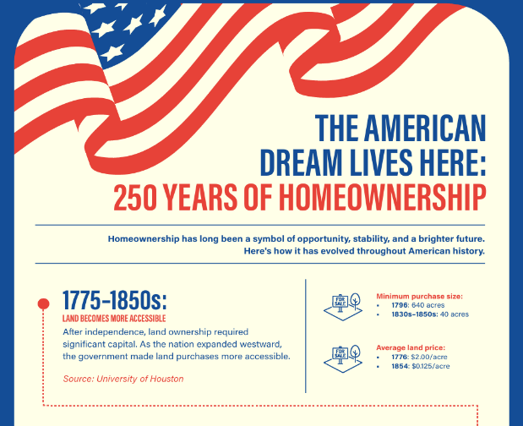 |  | SOCIAL MEDIA POST: Download and share this social post to show clients how homeownership has played a starring role in the American Dream.
 | INFOGRAPHIC:  Share this infographic to show how the role of homeownership has evolved in the American story, featuring space for your contact info. |  | 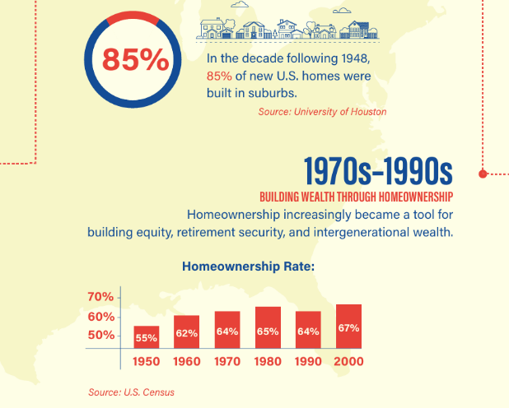
 | 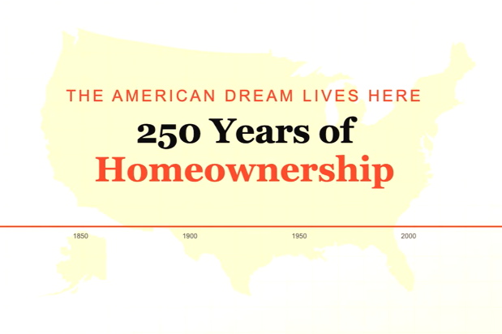 |  | CONSUMER VIDEO: ​​​  Share this one-minute video, The American Dream Lives Here: 250 Years of Homeownership.

 | TOP 5 TAKEAWAYS: Key insights to help you guide clients with clarity and confidence.
 |  |  | Access to homeownership for most Americans has expanded over time through government policy, land development, and financing changes.
 |  |  | The development of the suburbs after World War II had a profound impact on housing supply, making homeownership a reachable goal for new generations.
 |  |  | In the last half of the 20th century, homeownership became - and still is - a key method for Americans to build stability and wealth.
 |  |  | The foreclosure crisis of 2008 highlighted the risks that predatory lending and unstable credit posed to homebuyers.
 |  |  | Today’s consumers define the American Dream more broadly than achieving homeownership, but feeling secure in one’s home still plays a central role in well-being and prosperity.

Missed an issue? Visit the Consumer Trends and Insights archive on the CCRE website.
Disclaimer: Use of the materials contained in CCRE Consumer Trends and Insights must include proper attribution to Kantar, LLC. Attribution is already built into the downloadable tools, and members are asked not to remove or alter these credits when sharing with clients or the public.

This message was sent to %%email%%. Visit your subscription management page to unsubscribe or modify your email communication preferences. To update the email address to which this newsletter is sent, please contact your local association.
Advertising Inquiries: learn how you can advertise in this email newsletter.
CALIFORNIA ASSOCIATION OF REALTORS® • 915 L Street, #1460, Sacramento, CA 95814
Copyright © %%current_year_YYYY%%, All rights reserved.

